Solution

Step 1: Open the **S-Tools.** The following snapshot shows its user interface.

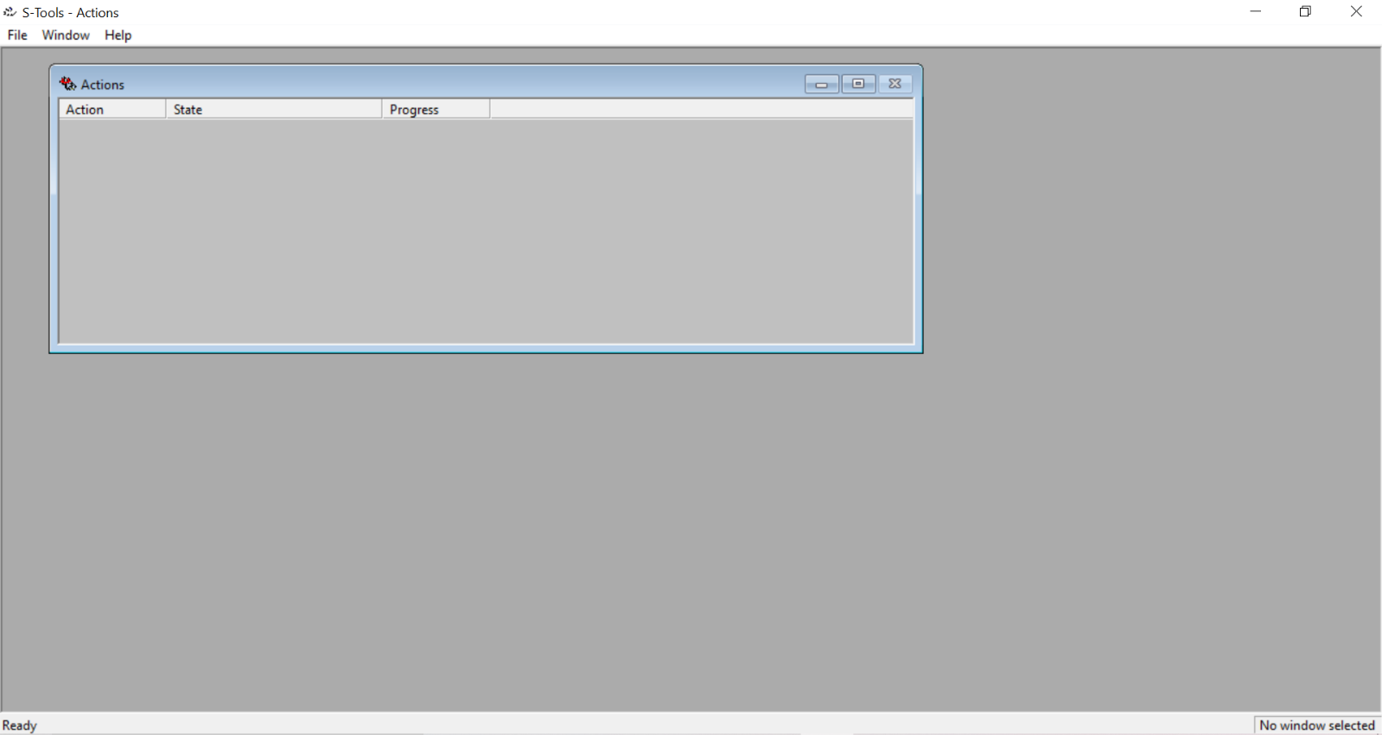

Step 2: Drag and drop the [Project3.bmp](https://github.com/sakshi0502/ITmasters_solutions/blob/master/Project%203/Project3.bmp) image and right click on it. Then, select Reveal option & then enter the Passphrase as **DigitalForensicsShortCourse2015.** And change the encryption algorithm.

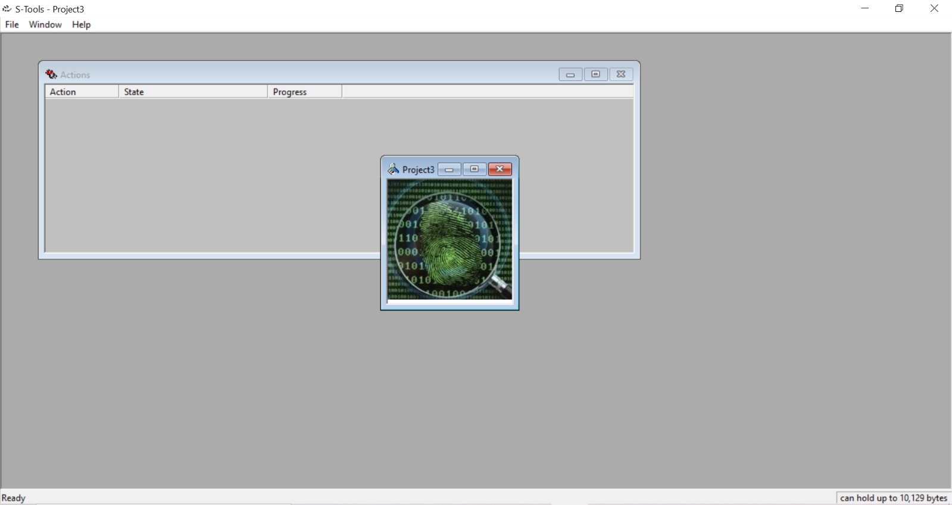

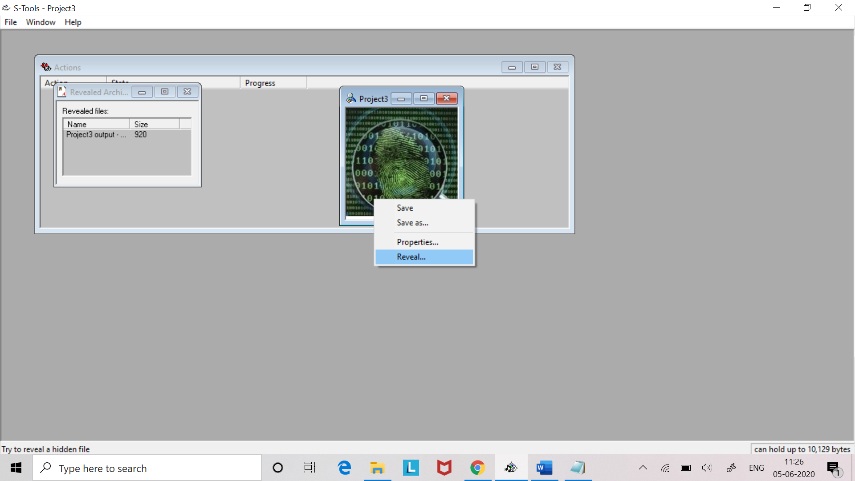 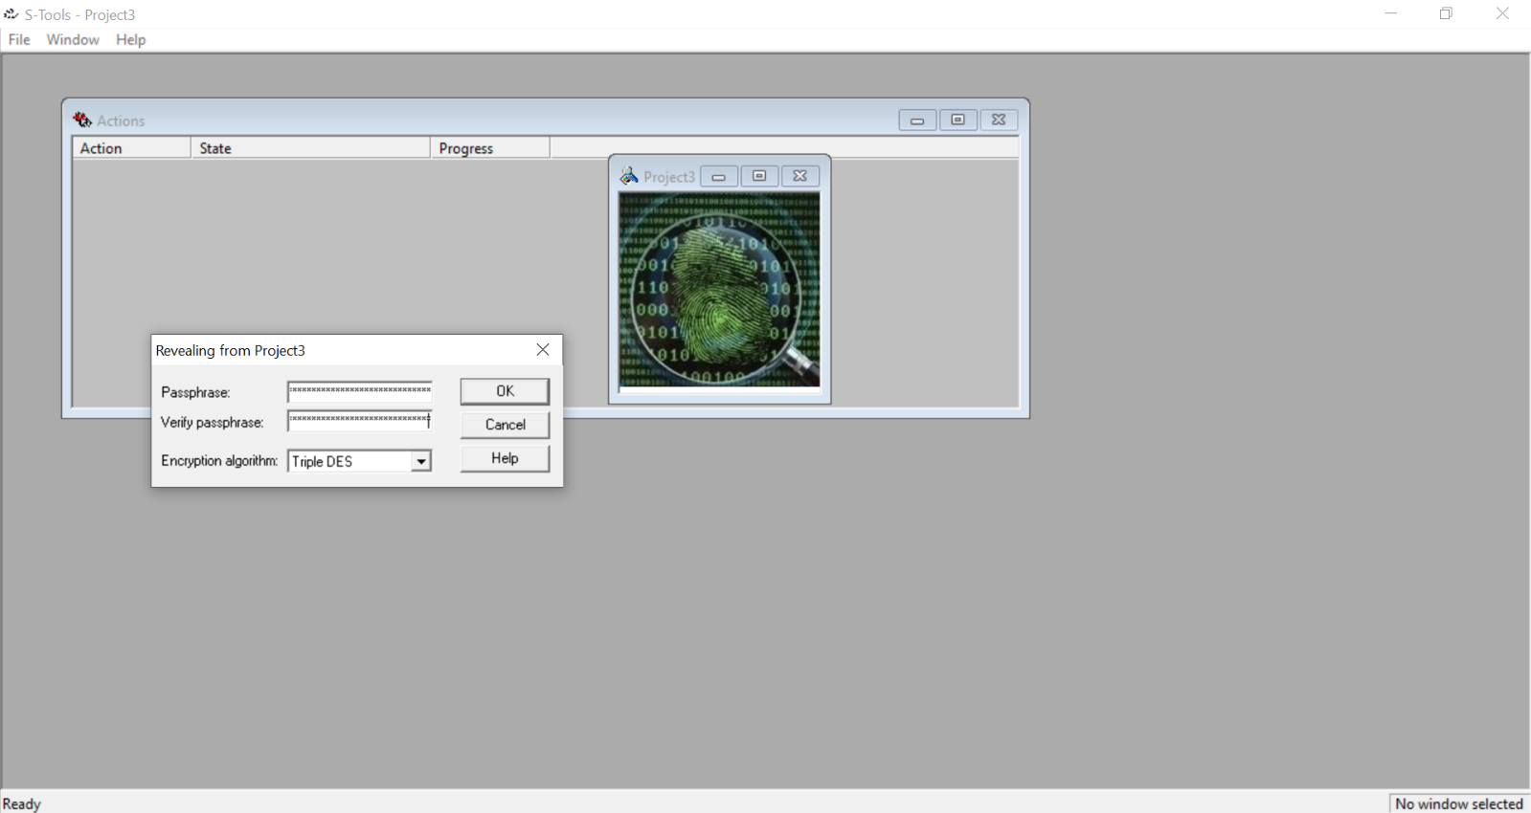

Step 3: Algorithm Triple DES works right and it revealed a text file. Right click on the file and choose **Save as** option to save the file in your system.

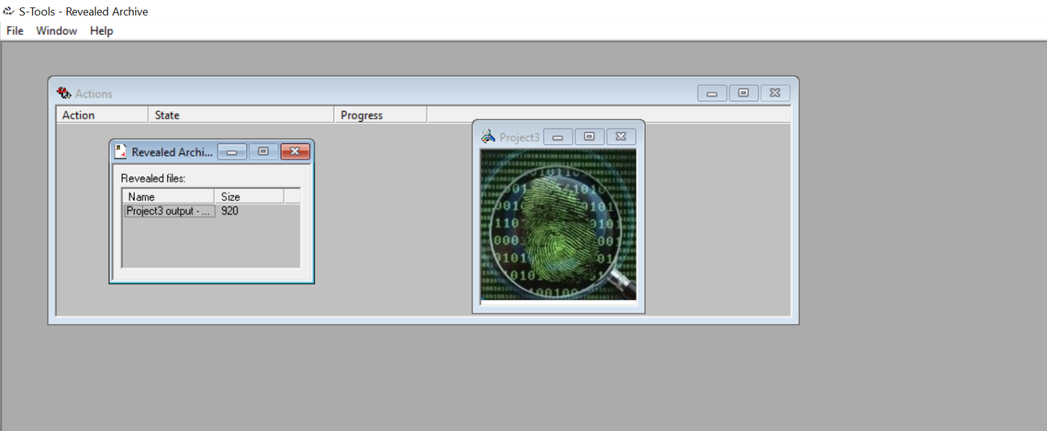 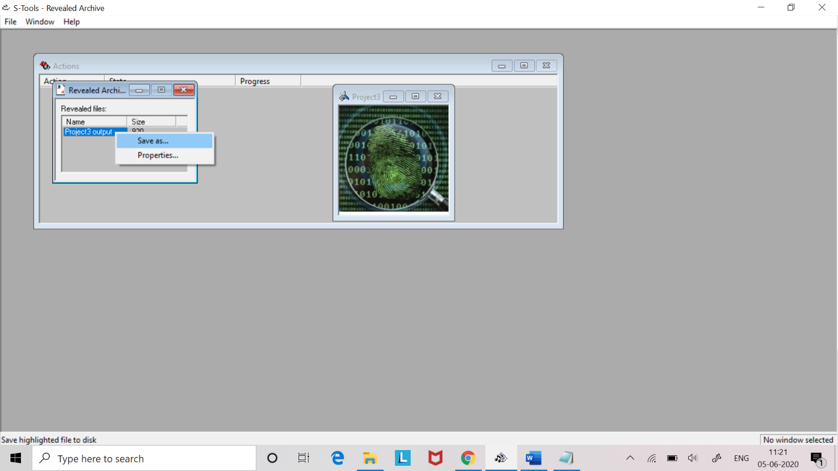

The hidden text is shown in the following snapshot:

